AXON SALES DATA ANALYSIS

**Odin School**

**Data Science Boot Camp**

**Capstone Project**

**Student’s Name: Jatin Dumka**

**Student ID: S4163**

**Problem Statement:**

A small company Axon, which is a retailer selling classic cars, is facing issues in managing and analyzing their sales data. The sales team is struggling to make sense of the data and they do not have a centralized system to manage and analyze the data. The management is unable to get accurate and up-to-date sales reports, which is affecting the decision-making process.

To address this issue, the company has decided to implement a Business Intelligence (BI) tool that can help them manage and analyze their sales data effectively. They have shortlisted Microsoft PowerBI and SQL as the BI tools for this project.

**Tools Used:**

1. SQL
2. Microsoft Power BI

**SQL DATABASE:**

We all got these sample dataset from odinschool named as classicmodels which includes the the data of AXON Company .

The data set consists of following tables:

* Customers: stores customer’s data.
* Products: stores a list of scale model cars.
* ProductLines: stores a list of product line categories.
* Orders: stores sales orders placed by customers.
* OrderDetails: stores sales order line items for each sales order.
* Payments: stores payments made by customers based on their accounts.
* Employees: stores all employee information as well as the organization structure such as who reports to whom.
* Offices: stores sales office data

**BEGINNING:**

I used the sample data set and open it on MYSQL after executing all the codes there I saw a database created by the name of the classicmodels. I have noticed all the tables in the database and decided to clean the data in the power BI . There are no such calculation needed here from my point of view.

I Loads the data into the Power BI using the MYSQL connector and my all the tables are visible there.

**Step-1** I decided to clean the data first as because I saw many empty data, null values, unnecessary table, and too much irregularities in the tables. So one- by-one I cleaned all the table and make data usable and clear.

**Step-2** As the data is cleared now I am looking for all the tables so that I can create some path to start and to make calculation how I can gain some useful parameters for the company.

**Parameters –** Total Sales?

Total stocks?

Customers?

Net Profit? etc.

**Step -3** After the needed calculation I decided to go for the data visualisation process means creating the interactive dashboard so that the company can understand there companies’ growth within the last few years.

**KPI’s:**

**Key performance indicators** (KPIs) refer to a set of quantifiable measurements used to gauge a company’s overall long-term performance. KPIs specifically help determine a company’s strategic, financial, and operational achievements, especially compared to those of other businesses within the same sector.

1. **Total Sales - $9.6M**
2. **Total customers - 94**
3. **Total Credit Limit - $7.8M**
4. **Customer Retention% - 96.81**
5. **Sum of quantity in Stocks - 555K**
6. **Total Quantity Ordered -106K**
7. **Total countries - 19**
8. **Total Cities - 74**
9. **Total Shipped orders – 303**

These are some KPI’s which helps me in this project to derive some useful insights.

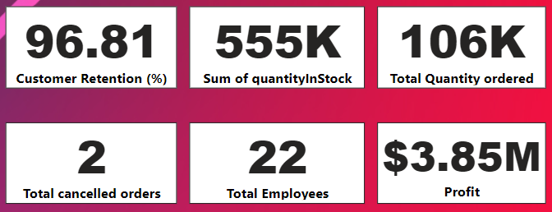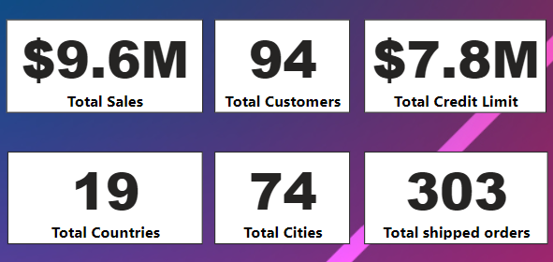

**CHART’s AND INSIGHTS:**

**SUM OF QUANTITY ORDERED BY THE COUNTRY AND CITY:**

The Country USA ordered the max quantity followed by the others Spain, France ,Australia, etc.

The City Madrid ordered the max quantity followed by the others San Rafeal, NYC, Singapore, etc.

**TOP PERFORMING PRODUCTS IN LAST YEAR( MONTH WISE):**

**TOP 10 PRODUCTS BY SALES:**

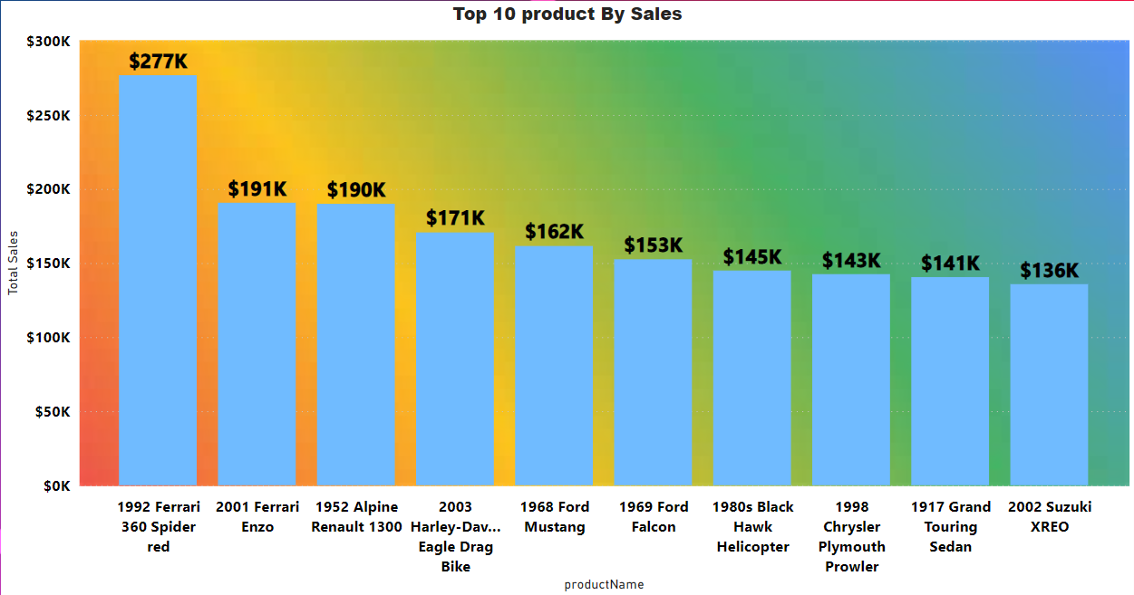The highest selling product Is **1992 Ferrari 360 spider red** with total sales of **$277k.**

**CONCLUSION:**

Axon's sales Company gained clarity, empowering decision-making through interactive dashboards and insights. I hope this finds well to the company and they can be able to take some useful steps from my report.

**Thank You**

**Jatin Dumka**